Cell line name | BIHi005-A_Exno20_SNP clones
Parental cell line name: | BIH005-A
Genetic modification | MutA: 1:23408767 T>C
Sample ID | SB01
Passage No.
Date of testing | 2023-10-09

Verification of the intended edit

Gene edited: KDM1a

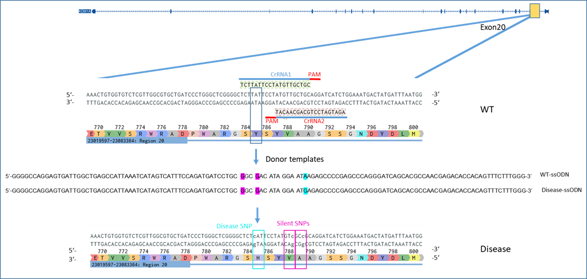

Verification by PCR followed by Sanger sequencing:

Primers used
Name | Sequence | Size
KDM1a-Exn20_Fw (812) | CATCACTTGATCACTGGCTCTC
KDM1a-Exn20_Rev(813) | GAAAGGGTCCGAAGATGGAATG | 400

PCR pipetting and conditions
Component | Reaction Mix 30 ul)
2x Phire Taq Buffer | 15 µl
10 µM Primer 812 | 1,5 µl
10 µM Primer 813 | 1,5 µl
gDNA | 2 µl
Phire Taq | 0,75 µl
Nuclease-Free Water | To 30 µl

STEP | TEMP | TIME
Initial Denaturation | 98°C | 5'
40 Cycles | 98°C | 5''
 | 60°C | 5''
 | 72°C | 5''
Final Extension | 72°C | 3'
Hold | 4°C

Sequencing with 812 primer

Results:

Chromatogram alignment of WT and edited clones
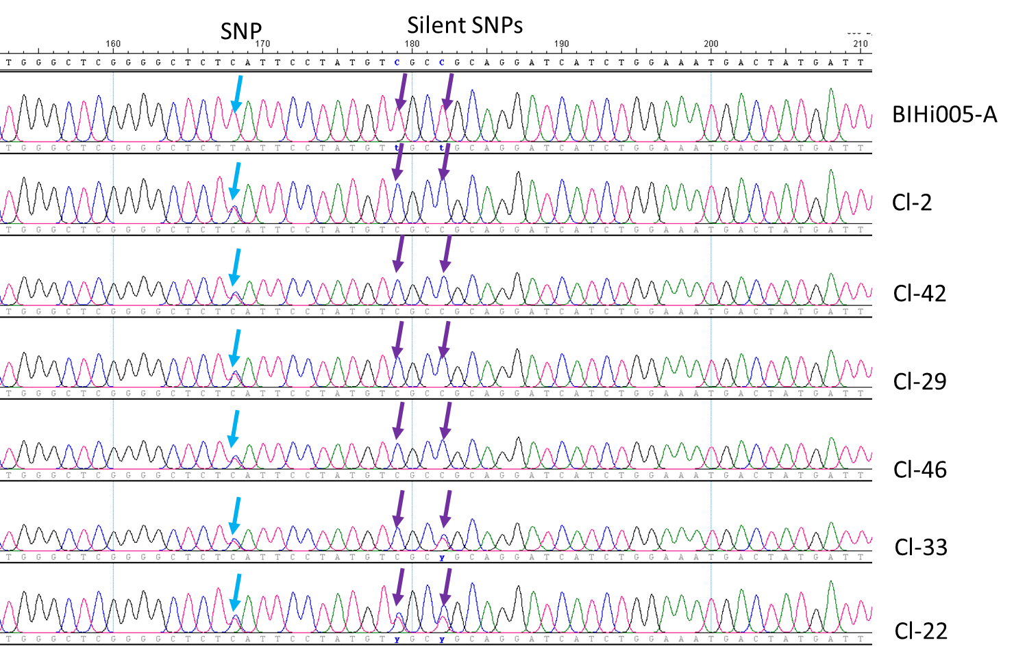
Alignment of the sequences from the parental BIHi005-A, and edited clones with edited sequences highlighted.

Conclusion

Sample tested contains designed genetic modification. The clones carrying heterozygous modification.

Date: 10/18/23
Narasimha Telugu

